The story of the adventures and rebuild of the Troy yacht Barbara, T12

By Marcus Lewis.

Troy Class Yacht number 12, named Barbara, was ordered from A.H. Watty, Boatbuilder, Fowey, on Jan 20th 1947. Arthur Bate, from Polruan, ordered her on the day his daughter, Barbara, was born. When visiting his Wife and newborn daughter that evening, rather than announcing he had paid a deposit on a house for his family, he announced he had ordered a Yacht!

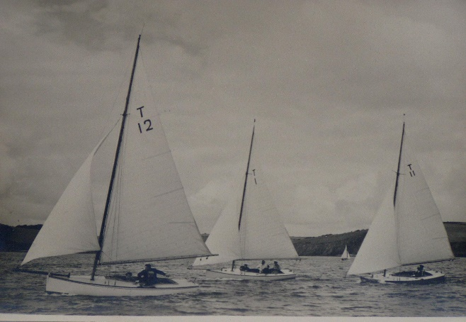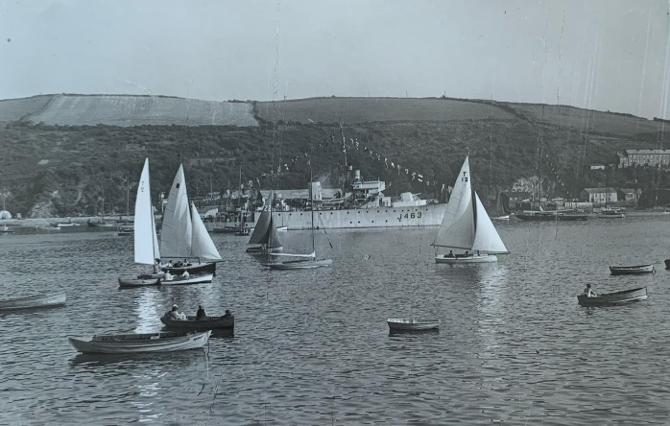

Arthur Bate raced T12 Barbara for the next few years, improving his results dramatically and had been very successful in Barbara in 1951, '52, and '53. He moved away from Polruan in 1953, selling the boat to Mrs Gilchrist of Fowey.

She owned Barbara, for four years, selling her to Miss N Bradbury in 1957.
It seems the Troy fleet was in a bit of a decline around that time, as when Miss Bradbury put Barbara up for sale in 1958, she was bought by Commander Campbell and taken to Padstow, on the River Camel. He fitted her with a Stuart Turner engine to help beat the tide in the estuary, and effectively the 12th Troy became lost to the Fleet, as far as we know not looked for or thought about.

In the early 80's Richard Kitson (T10 crew) and Marcus Lewis thought about trying to track down the Troys that were missing from the fleet, and from this ended up purchasing Janet T3 from Gateshead. (A whole other story). Many hours were spent behind the Lewis’s sweet shop in their search. It was at the re-naming of Janet in 1984, (Janet naming pic) that Radio Cornwall presenter Tamsin Thomas interviewed Richard, and appealed for information on any of the other Troys missing from the fleet.

Following the Radio Cornwall appeal in 1984, some 25 years after Barbara went to the River Camel, a boatbuilder from Padstow got in touch. In the 60's, Barbara fell over when the tide was out, and damaged her side, while she was being repaired, the owner died, and Barbara passed to his nephew. It was his intention to set up an 'Outward bound' style training centre in the Outer Hebrides when he came out of the Army, so he sailed T12 around Lands End, along the South coast, up the East coast, had her shipped overland across Scotland, then sailed her out to the Hebrides. Finding out Barbara was in the Outer Hebrides was a surprise, we had the owners’ details, so wrote to him to see if he still had her. He did, sort of.
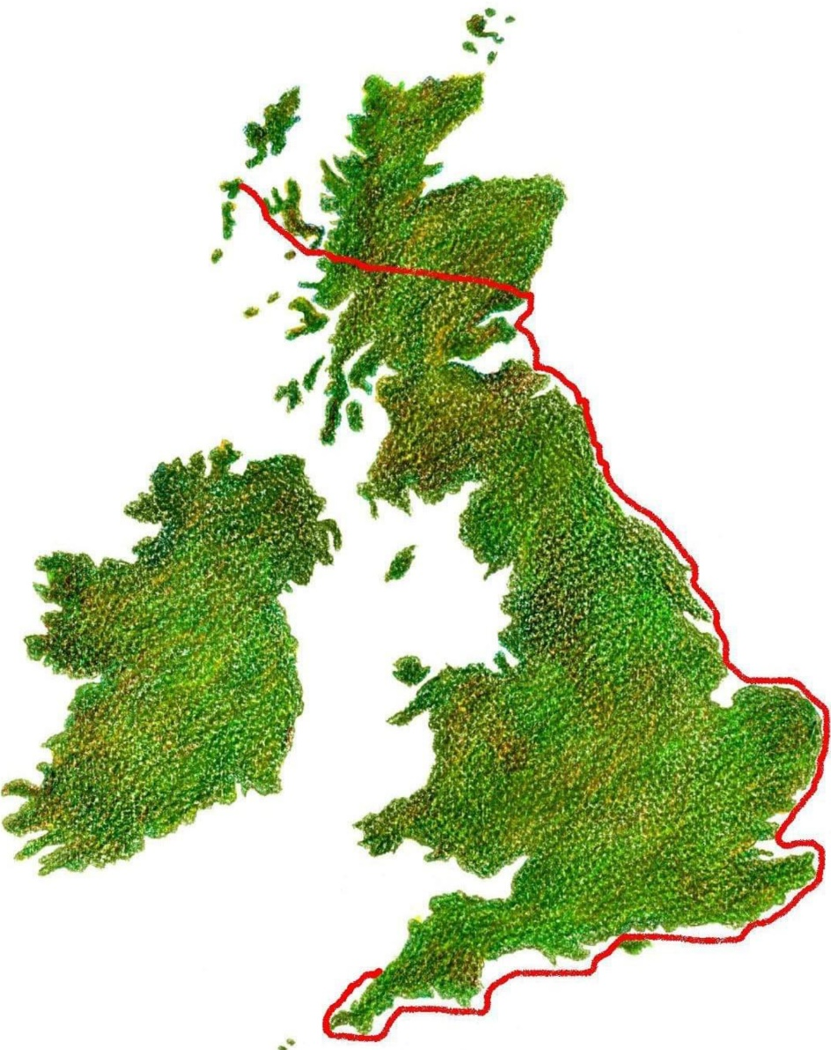

T12’s Voyage to Scotland Voyage in landing craft
He told us she had sunk in a gale some 15 years previously and had been dragged up onto the beach. Not having the skills to repair her, or the money to pay someone else to repair her meant she was falling apart alongside his stone quay.

He did offer her to us, but we had just renovated Janet (T3), and didn't need or want another Troy. So, we got in touch with Arthur Bate, Barbara's original owner, to see if he was interested in rescuing her, which he was. Sadly after 5 or 6 years of trying, he gave up trying to rescue Barbara. I was still curious, but she was on a small island off Benbecula, and not easy to access. S I and my partner, Sue, took a trip to the Outer Hebrides. We discovered that time hadn't been kind to Barbara, and she had deteriorated badly in the 6 years since the last photos.

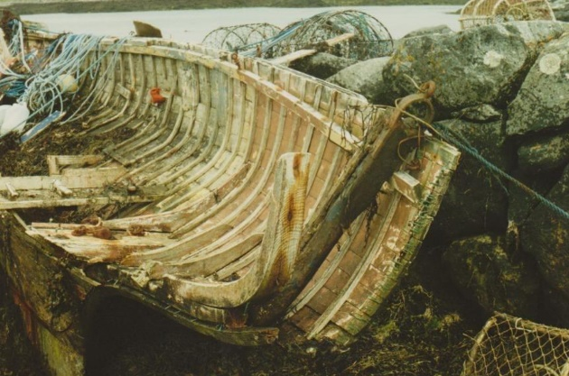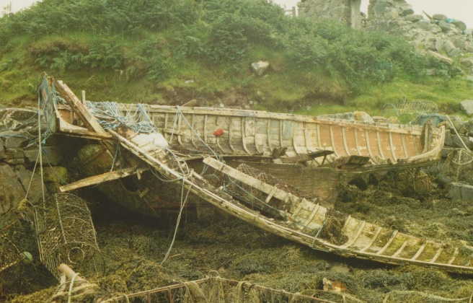

This was as we found her with the starboard side broken away

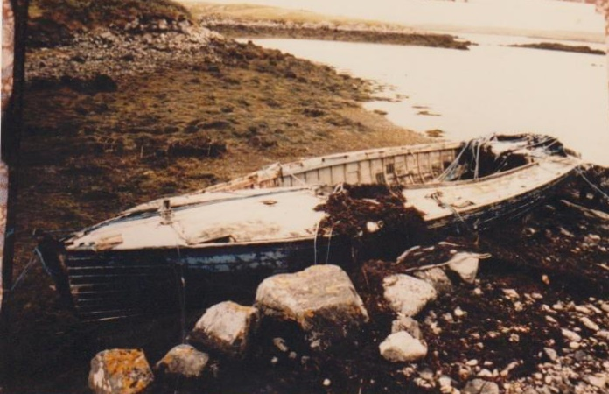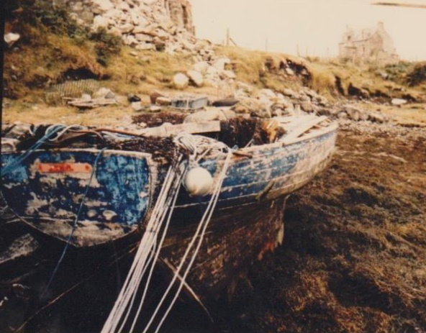

We met the owner, saw the boat, and came back home, and started discussing with Richard, how to get her back. To rescue Barbara would involve a few challenges.
They were: -
1. She was on the far side of a boggy island with no roadway, so she had to be floated around the island to the causeway, and pulled out of the water.
2. She was in no state to float
3 She wasn't in a fit state to sit on a trailer for a journey the length of the country,
4, - 5 AND
6..the more you thought about it, the worse it got !

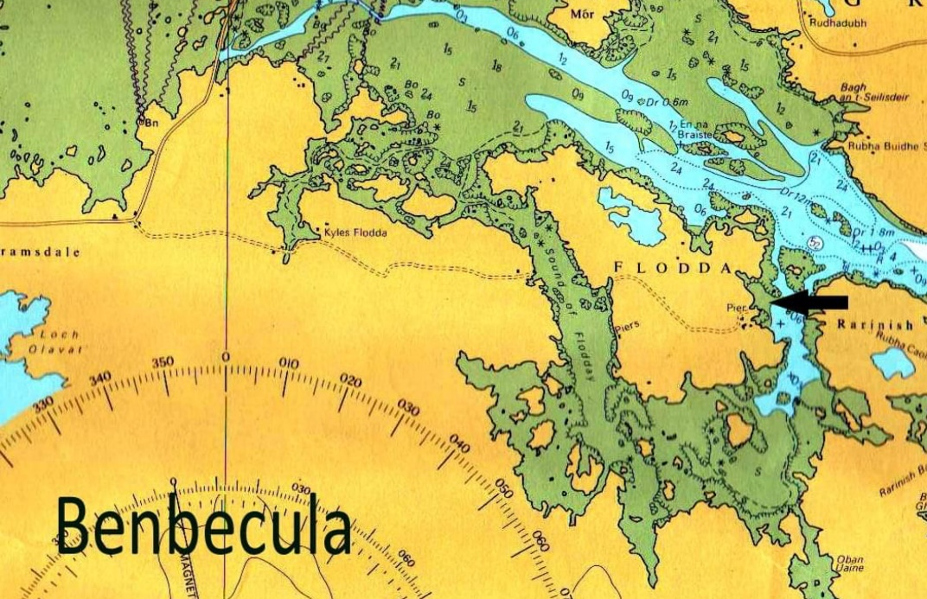

Where Barbara was located

We returned home and after talking to various people around Fowey, and listening to various suggestions, Major Tony Parkyn offered some help. Army Landing craft from Marchwood, Southampton, run supplies to the Hebrides in the summer, and come back to Southampton in the autumn. If we could get Barbara 10 miles south to the jetty, an Army supply ship could pick her up and bring her back. A big if. Our only job was to get her to the Jetty so, in the autumn of 1990 we headed up to Benbecula again to get her shifted to the Jetty.

We left Fowey, Sue, and I, in Richards highly versatile Ford Orion loaded with things we might need, straps, ropes, hammers, nails, lengths of 4x2, tirfor winch, shackles, wires, and a whole lot more. On arrival at Island Flodda, we met the owner, had a chat, he could get a mate with a motorboat to tow her around the island if we could get her to float.

We headed off to Benbecula, managed to get past the armed guards at the RAF base, and asked them ever so nicely that if we got Barbara to the causeway, could they send a lorry to pick her up and transport to the Jetty, which they could. In order to get her to float we managed to borrow 5 - 40gallon oil drums form the airport Fire Brigade, strapped them to Richard’s roof rack, and headed back to Barbara. Once she was all strapped up, and nailed together, we had to sit and wait for the tide. The tide came in, and she floats.
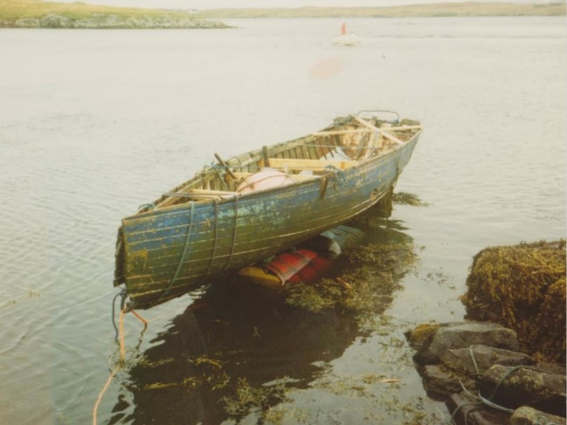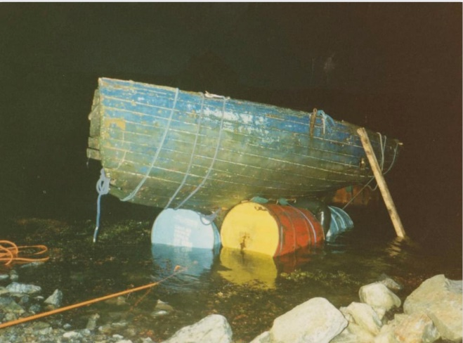
Colin Campbell’s mate turns up with his fishing boat and tows her around Island Flodda where we pull her ashore in the dark, prop her up, and hope she is still upright in the morning. The next morning to our relief she is high and dry, and still upright. The plan now involved taking off all the oil drums, etc, and winch her up the slope onto the roadway. The Ford Orion was positioned stern too across the roadway, the Tirfor winch attached to the tow bar, greased boards were levered under Barbara's keel, and chief winch operator, Sue, began to push and pull the winch handle, the wire tightened. Overcoming the initial friction proved to be the hardest pull, and then it MOVED, yes, the Ford Orion was skidding backwards towards Barbara! After chocking the wheels with stones, and trying again, eventually we made it, chocked her up and went back to the B and B.
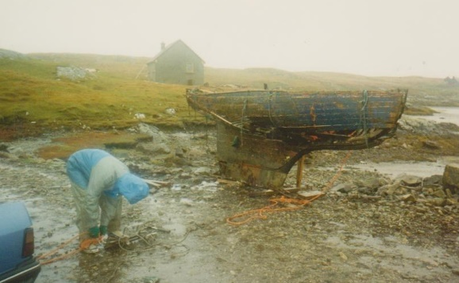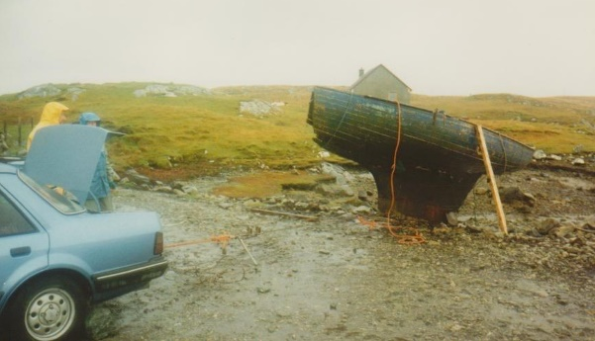
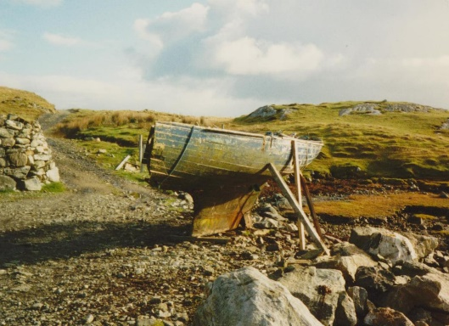
The winching ashore operation
The ferry was booked for the next morning which was a beautiful sunny day for a quick visit to check on Barbara before we caught the ferry to the mainland and the long drive home. She was left in the care of the RAF alongside the causeway who then picked her up and carried her the ten miles South to the Jetty where she waited for the Army supply ship. When we arrived back in Fowey there were messages for us to contact the ship, via fax, the modern way of communicating then. The Harbour Office were one of the few places with access to this hi-tech stuff, and there was a bit of a hitch. The ship’s captain deemed Barbara too fragile to carry. To get over this we messaged the ship absolving him of any blame for damage, but he was still reluctant. It was a bit of a surprise a week or so later when Harbour Master, Capt. Mike Sutherland phoned me and asked to arrange a crane on the Jetties. Barbara was due in later that day. The original plan had been to land the ships ramp on Caffa Mill slipway.

Hastily arranged docks crane and trailer, and the ship came in. Looking into the hold when she was alongside revealed 3 pallets, all separate, one had the bow section on, one the stern, and the keel and lower planks on the other, not quite what was expected, at all. Apparently there had been problems loading her, and she was fragile.

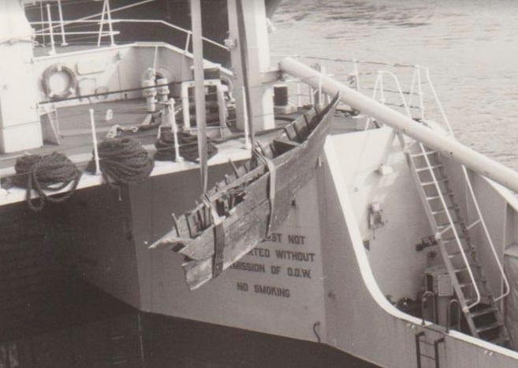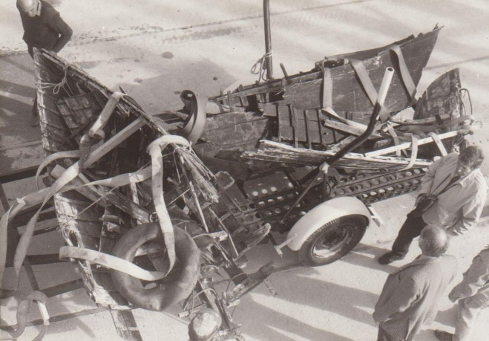

Lifting out of the landing craft and the bits loaded on a trailer

It was really disappointing to see Barbara in 3 pieces, but, the following day started to disassemble the wreckage, keeping the main oak timbers from the centreline, the main deck beam, and of course the 16-cwt lead keel. This was 1990, and the keel was put away in the garage, the main timbers were stored in a friend’s barn, and the plan was to rebuild her when space and time permitted.

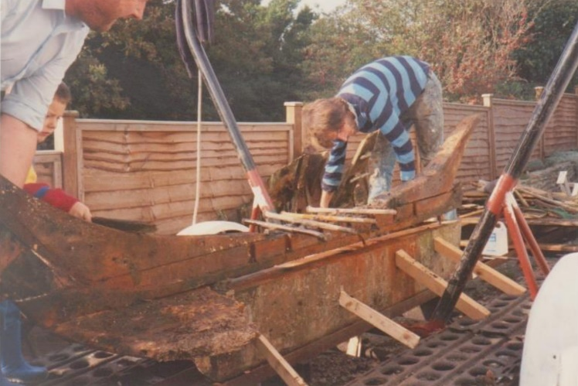
Roll on 25 years, and the space became a possibility in my new workshop at Windmill in Fowey. The keel was cleaned up, dents and scrapes flattened out, and set up level. Looking at the old timbers it was decided that none of them were up to being used again, so a new centreline of solid Oak was cut out and set up on the keel. Then the moulds used to build troys within the rules were set up in position.

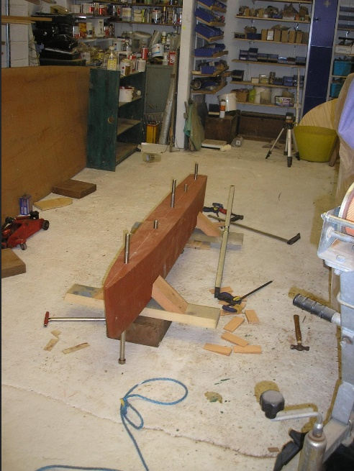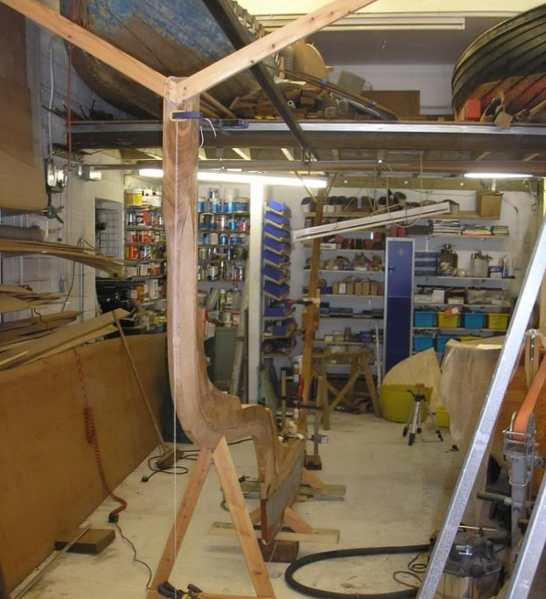

The keel all faired up and the new stem post in place

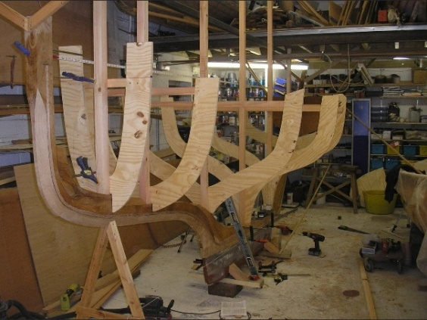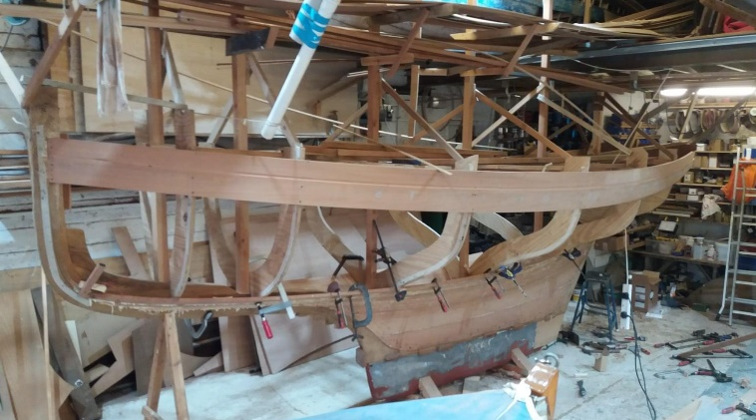

Over the next 5 years, little was done to the new Barbara, a few planks had been fitted to the shape of the Troy owners moulds, but that was it.

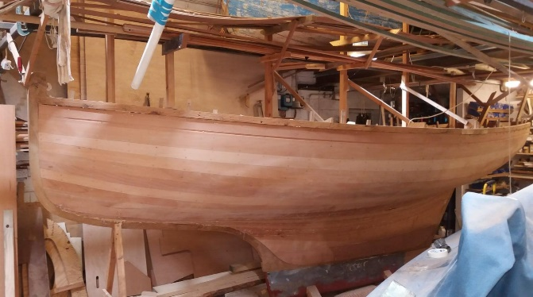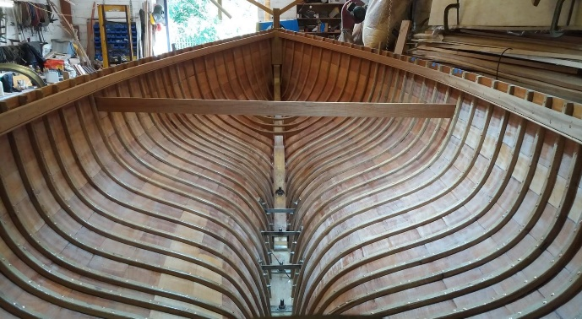
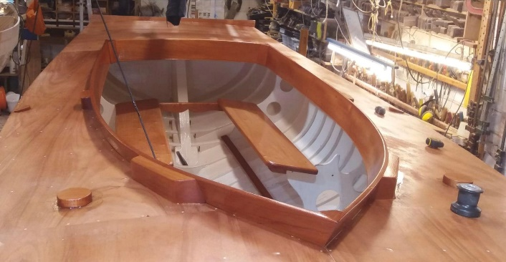

When lockdown hit, in March 2020, work on customers boats came to a dead halt, no-one was sure what was going to happen, so on the second day of lockdown I started start again on Barbara, manging to do the majority of the work on the hull alone, but with some help from socially distanced friends when it came to riveting the nails. Work carried on, and by May 2021 she was ready to be launched. Barbara had been reborn with the help of to a pandemic

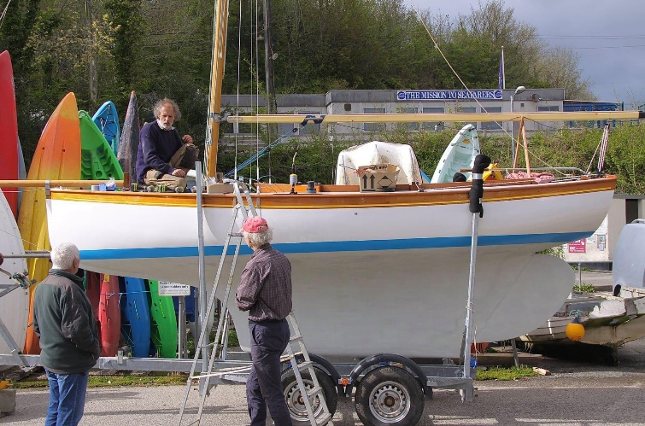

Ready for launching inspected by Louis Saget and Buzz Barclay

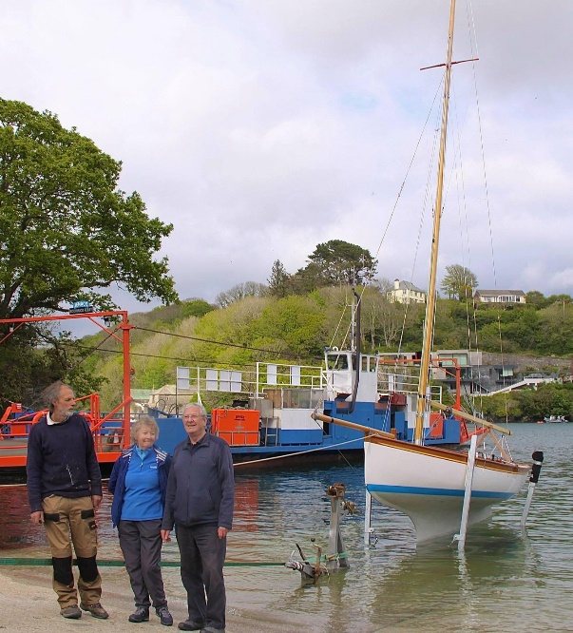

Me,mt Partner Sue and Richard Kitson ready for the launch

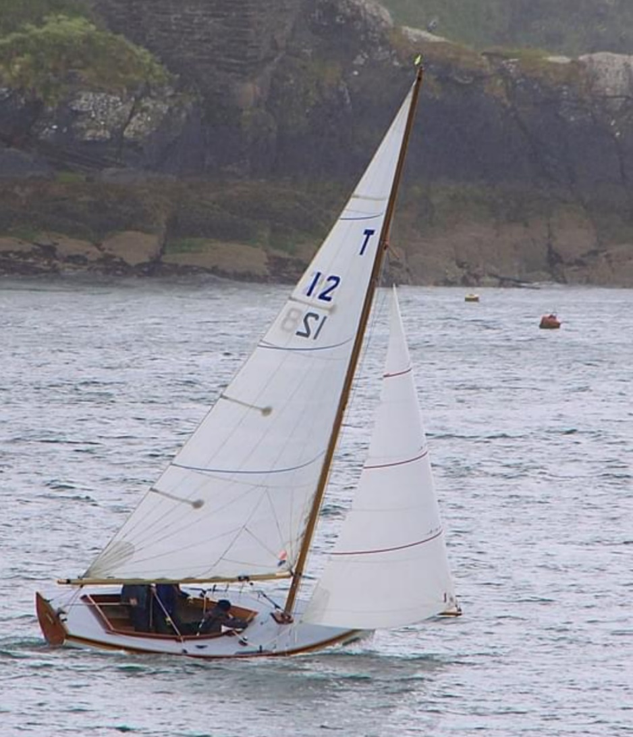

Racing again

THANKS
There is no way this project could have happened without an awful lot of help from a large number of people, including the Army and RAF, and Barbara is now back racing in Fowey Harbour where she was meant to be.

