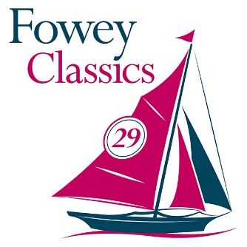
Trophy Winners 2022
The Gribbin Cup | Gelvynek – Jeremy McCabe  For best small boat
Ungley Petard | Sybil – Cornelius van Rijckevorsel  For best Bermudan yacht over 20ft
Top Prop | Moonbeam of Plymouth – Dorothy & John Merrett  For best mechanically powered vessel
Ansome Transom | Roxanne – Martin Elliott  Best boat overall
Trafalgar Cup | Ayesha – Richard Bond  Best boat overall in Trafalgar Cup Race
Tomboys Old Topsail Block | Wonder – Ian Barker
Wee Wellie Trophy | Wonder – Ian Barker  Best dressed / presented boat
Fowey Classics Troy Trophy | Barbara – Marcus Lewis
Fowey Classics Fowey River Trophy | Zethar – Philip & Sian Henson

