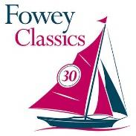
West Country Classic Series 2023
Prizegiving
Sponsored by
You are cordially invited to the West Country Classic Series prizegiving and buffet lunch at Saltash Sailing Club, Tamar Street, Saltash, PL12 4EL on Saturday 2nd December at 12.00 noon for 12.30. Prizegiving will be followed by a buffet lunch, cost £15 per person to be paid on the day. Complementary drink on arrival.
RSVP to Bruce Thorogood email: bruce@classic-channel-regatta.eu by Friday 24th November.
The West Country Classic Series is run by the Falmouth, Fowey and Dartmouth Classic Regattas. Entries must be over 5.5m/18ft LOD and must have competed in at least two of the three regattas. Scoring is based on overall class position in the individual regatta and the CoxSprague system is then used to combine those results into an overall place.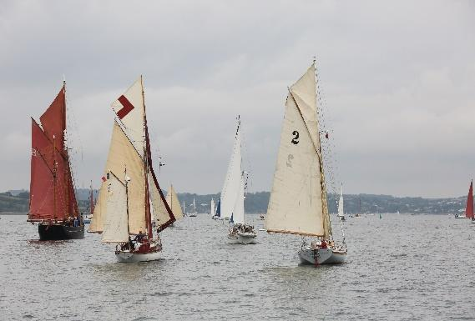
We very much look forward to seeing you in Saltash and celebrating this year’s 2023 Classic Season.
Hattiers Rum – Traditional Rum roots plus pure Devon soul www.hattiers.com The Distillery Hay Farm, Mothercombe PL81JZ 020 7170 4566

Buffet Lunch Menu
West Country Classic Prizegiving
Vegetarian Quiche
Melon Eden (with Prawns & Smoked Salmon)
Coronation Chicken
Mixed Charcuterie
Tomato & Basil Salad with Mozzarella
Mixed Leaf Salad
Beetroot & Bean Orange Salad
Rice Salad
Coleslaw
Selection of Bread Rolls
New Potatoes with Chive Butter
****************************************
Lemon Meringue Roulade
Fruit Salad & Cream
Image: Nigel Sharp

