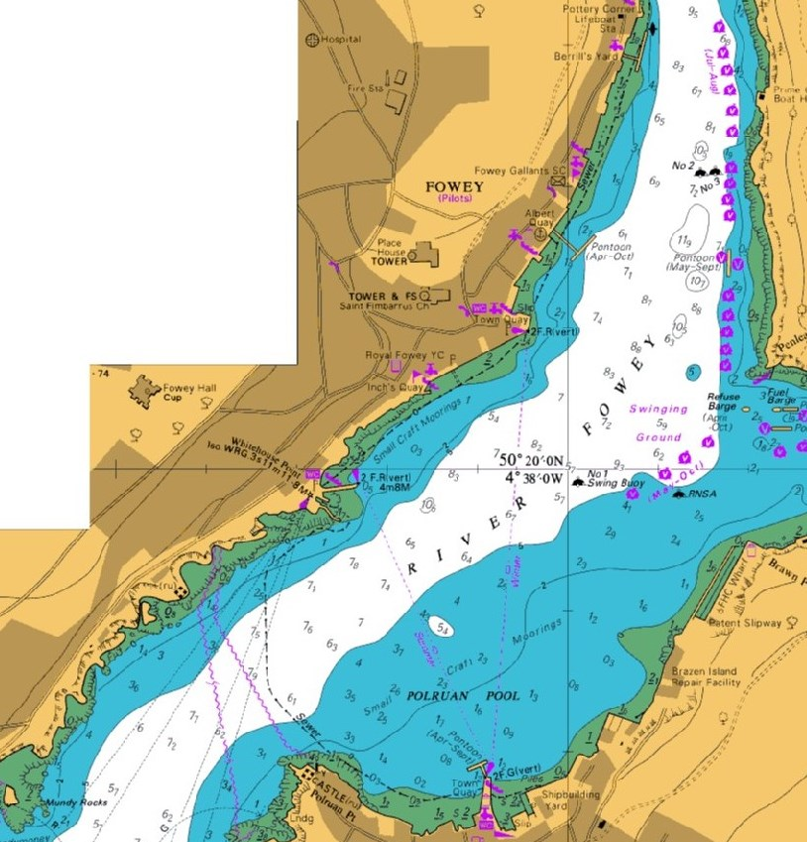

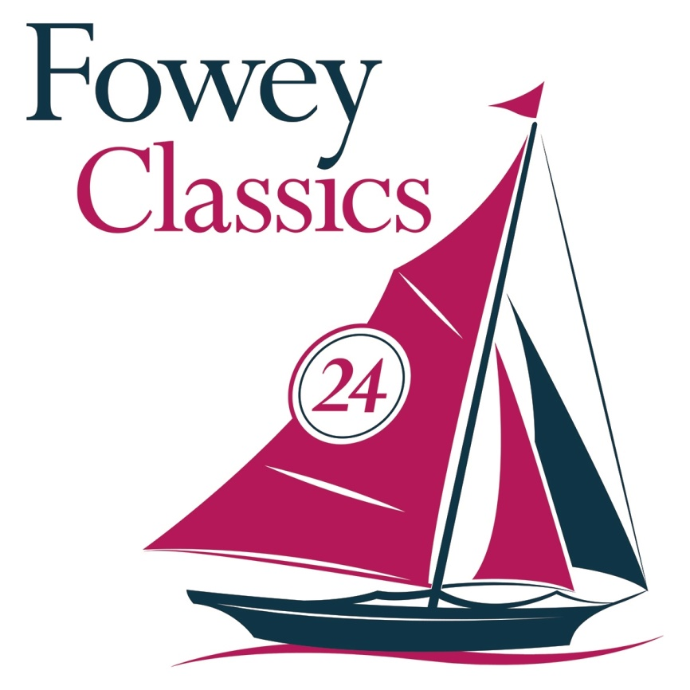

**FOWEY CLASSICS 2016**

**PARADE OF SAIL COURSE**

There will be two turning marks to guide participants in sailing around the parade of sail. The course will be clockwise around the marks the northern one off the Albert Quay pontoon and the southern one off Polruan Castle. Leave these marks to starboard. If it is congested at the turning mark turn earl or wide to avoid collisions. Safety is paramount so please ensure there is sufficient room to manoeuvre. Winds in the harbour can be fickle. Anyone can join in at any part of the parade.

Enjoy and thanks for participating

Reproduced by courtesy of the Hydographic Office, Taunton

North

Mark

South turn

mark