Information sheet 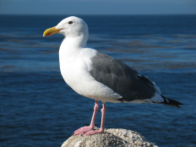
Be safe crossing the harbour in tenders. Show a light at night and wear a lifejacket. There are lockers at both pontoons
Please don’t feed these
But the swans are OK

TIDES DURING FOWEY CLASSICS 2023 EVENT.
Day and | High Water |  | Low Water
Date | Time | Height | Time | Height
25th July 2023 | 10.53  22.59 | 4.4 m  4.6 m | 04.36  16.52 | 1.5 m  1.7 m
26th | 11.40  23.51 | 4.3 m  4.4 m | 05.19  17.43 | 1.6m  1.8m
27th | 12.39 | 4.3 m | 06.18  18.56 | 1.8 m  2.0 m
28th | 00.58  13.53 | 4.8 m  5.1 m | 07.40  20.24 | 1.9m  1.9 m
You will have noticed that we’re holding the event are during the neap tides. So moderate currents to worry about. Heading in or out of the harbour they can be quite strong if sailing especially with light winds. If rowing across the harbour in dinghies allow for the set and it may take you a bit longer.
Better still and the safest option is the water taxi with their two light blue craft.
There’s a new owner and “Stubbles” has retired. Tony Dagger is your man with the water taxi now. It is Cash only on the water taxi
SO, IF YOU NEED A LIFT ASHORE OR BACK AFTER STRETCHING YOUR LEGS
ASHORE OR SEEKING REFRESHMENT THESE ARE THE CONTACTS
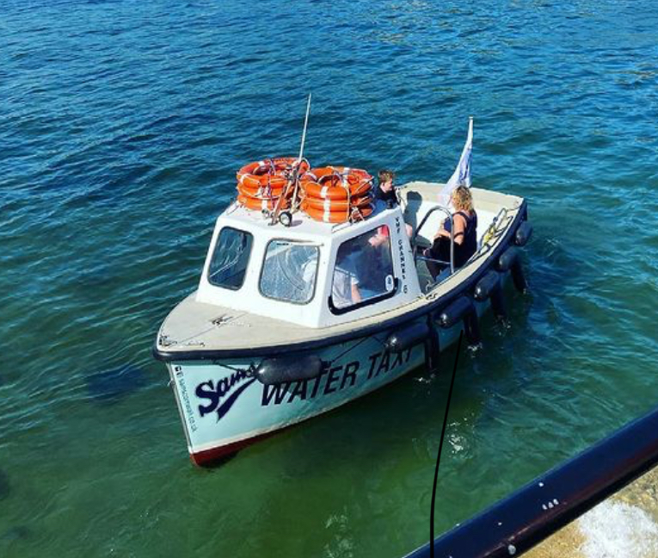
VHF RADIO CH:6 Call Sign "Fowey Water Taxi"
Mobile 07774 906730
Email:- info@foweywatertaxi.co.uk
The Fowey water Taxi has a website:- https://foweywatertaxi.co.uk
NEED A MARINE ENGINEER
If you are unfortunate and have a breakdown or other problem aboard the boat, there is lots of help in Fowey.It comes in all sorts of shapes and sizes. Here is a list of help.
Fowey Harbour Marine Engineers 01726832806 (workshop) 07770600083 mobile.
Mixtow Marine 01726832471 at Penmarlam 07802724028 mobile
Toms Boatyard Polruan 01726870232
Sail Shape Marine:-Telephone: 01726 833731
E-mail: jimmy@sailshapemarine.co.uk
Address: Unit 12 A, B , Restormal Industrial Estate, Lostwithiel, PL22 0HG

NEED A REPAIR TO THE BOAT or INTERESTED IN BOATBUILDING
Ever since ships sailed the seas Fowey has been blessed with many boat builders and boatyards capable of carrying out any repairs to boats and especially Classic craft. Listed below are some of those. While in Fowey they are always happy to show you their skills at their workshops.
Peter Williams Boat builder at Bodinnick north of the ferry 01726870987
Marcus Lewis, Boat builder at Windmill estate, Fowey 07973420568
Toms Boatyard builders of steel and wooden vessels, Polruan 01726870232
Tom Owen, Restorer of classic boats, Windmill Estate Fowey 07976403120
Louis Hunkin, Gig and boat builder, Millpool Yard, Passage Lane 01726832874
Graham A’Lee, boat repairs and maintenance, Fowey Boatyard 01726832194

IN NEED OF SOMETHING DONE TO THE BOTTOM OF THE BOAT

Lift outs can be arranged at Toms Boatyard or the harbour commissioners Penmarlam Boat Park and smaller craft at Fowey boatyard. There are slipways at Caffa Mill in Fowey and Penmarlam in Mixtow
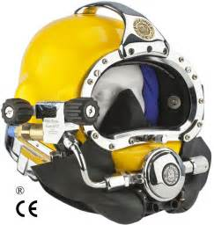
The tides are not bad for drying out, but a diver may be a better answer. One can be organised by the Harbour office or by contacting Sal Marine Services 01726 844749 or 07770598346. Diving permits are required in the harbour.

WHAT IF YOUR SAILS NEED A STITCH OR TWO OR A BIT MORE OF A REPAIR.

Fowey has a sailmaker to carry out those essential repairs, adjust or repair rigging and look after all your needs canvas wise.
Sail Shape Ltd are the boys.
Lostwithiel Production loft: Unit 3G, Restormal Industrial Estate, Lostwithiel, PL22 0HG, Cornwall 8am – 4:30pm Monday – Friday – All year
Telephone for all lofts: 01726 833731

SAILING CLUBS

The ROYAL FOWEY YACHT CLUB (RFYC) and FOWEY GALLANTS SAILING CLUB (FGSC) will providing a good Fowey welcome to all participants as they do for all visiting yachtsmen. Events associated with Fowey Classics will be held at the clubs

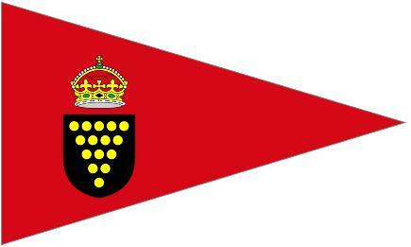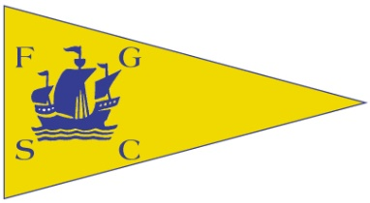

SHOWERS ETC

Both clubs have excellent showers and other facilities. These can also be found at Penmarlam boat Park operated by the Harbour Commissioners and at Toms boatyard where there is a laundrette facility.
CHANDLERY

There are Chandlery outlets at Toms Boat Yard and Mixtow Marine at Penmarlam and at Caffa Mill.

RUNNING SHORT OF MONEY OR NEED A POST OFFICE.

Like a lot of places services are getting less and Fowey doesn’t have a bank anymore. Barclays cash point is situated in Trafalgar Square near the Ship Inn where there is a hole in the wall. Money can be obtained from the post office in the Store in Fore Street and there is another post office in Park Road at the top of Fowey (Top Shop). Looks like the card will be the alternative.

EATING AND PARTICIPATING IN LIQUID REFRESHENT.

Now this is one of the best bits about a visit to Fowey. There are numerous watering holes all with good beers, wines and spirits to warm the cockles. There are far too many to mention all. Similarly, the good food establishments are numerous and to our knowledge all have a good reputation and a fine selection of different menus. Follow the good smell as you head ashore.

FOOD TO RESTOCK ON BOARD.

One of the smells that always draws mariners and visitors alike is the smell of freshly cooked bread. It comes from the Quay bakery now located in Fore St where the fish shop used to be. There is another baker towards the church where Niles serves pasties and cakes amongst other goodies. There are other choices for pasties including Kittow’s Butchers/ deli. Now this is worth a visit because here Richard Kittow will charm you with his tales and serve excellent sausages and other fine cuts of meat and delicatessens. If you find the church, you will be right next to his shop.

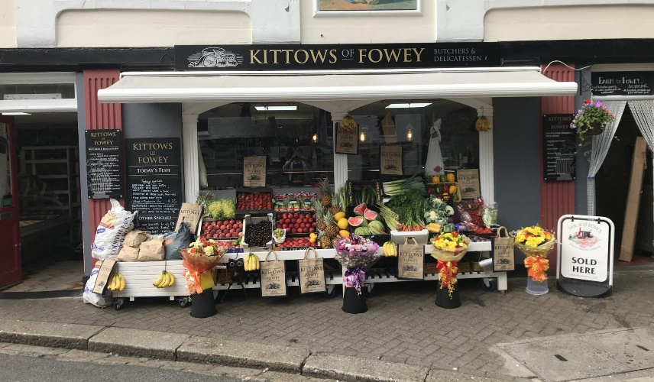

Email- orders@kittowsfowey.co.uk Telephone- 01726 832639 http://www.kittowsfowey.co.uk/
What else do you need? The Fowey Mini Market and Post Office in Fore street has a lot of the things you might need with post office and cash withdrawals.

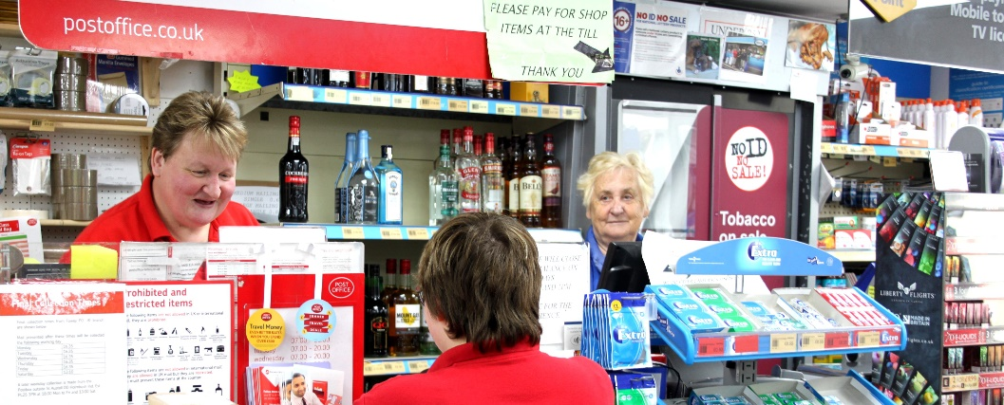

call them on 01726 833356. You can email them at info@foweyminimarket.co.uk. https://foweyminimarket.co.uk/
Where’s one of the best places to find anything out? – pop into the harbour office and see the girls in there. If nothing else, they love a chat.

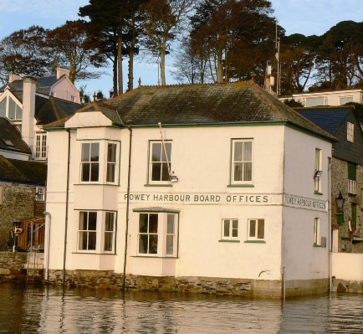

MEDICAL HELP 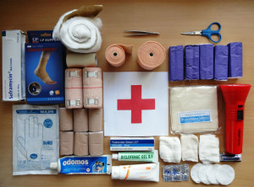

Our hospital along with many other cottage ones has closed so it’s off to St. Austell or Truro or perhaps even Derriford in Plymouth if you need hospital attention. We have a doctor’s surgery and the staff in Boots Chemists is always extremely helpful.

If you have a medical emergency on board call the Harbour office on Channel 12 or the Coastguards who will arrange what is needed.

There is a VHF relay on Polruan headland to enable communications with Falmouth Coastguards.

NEED A TAXI OR BUS

Call KP Cabs, based here in Fowey on 07857636881

There are bus services. You can get the town bus outside the church to get to the top of town or the main bus to places beyond Fowey from outside the Safe Harbour pub (head up beside the church)

Things to do

There may be time to do other things than sail, eat, drink, and generally chill out.

How about getting in the dinghy and heading up the beautiful estuary past the commercial jetties to Golant , Lerryn or even Lostwithiel (you will need the tide to be OK)

There’s the Hall Walk for those who need to stretch the legs. Head to Polruan or Bodinnick and the walk takes you around through Pont. There’s a pub at each end.

Or walk out to the Gribbin – too far? well stop at Polridmouth.

There’s also a great little museum all about Fowey things adjacent to the Town Hall and of course the aquarium all in a stone’s throw of town quay with the Fowey aquarium nearby.

And for the really desperate some shopping.

Enjoy your stay in Fowey. Have a safe passage to and from Fowey and come back again

