The Fowey River Class
The Fowey River class dinghy is based on the Yachting World 15ft knockabout dinghy designed by Reg Freeman in the late 1930's. The plans were published in Yachting Monthly magazine in April 1939 to try and encourage people to build their own boats from plans that were available to purchase through the magazine. After the war the design was again publicised in Yachting Monthly in November 1945 issue. The clinker hull with gunter rig was adopted by the class since its inception in Fowey.
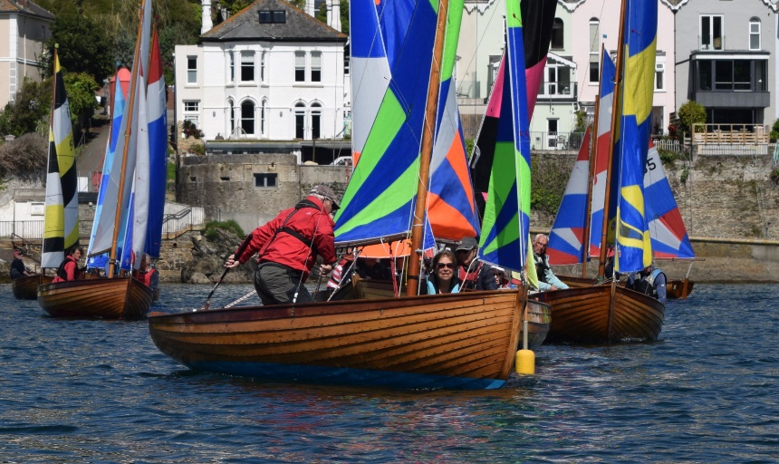
In the early 1950's, Hunkin's Boatyard at Polruan built one of these knockabout boats for the local dentist Mr Mogg, ( Moggy) who named her Michelle after his daughter. by 1957 15 more boats had been built by Percy Mitchell at Portmellon, Watty in Fowey and Toms in Polruan. Numbers gradually increased and there were 36 boats eight years later. From then on the fleet went into the doldrums with potential owners opting for other craft. Regatta week was always the exception with skippers and crews bringing them out of storage for a week’s racing and of course Polruan regatta.
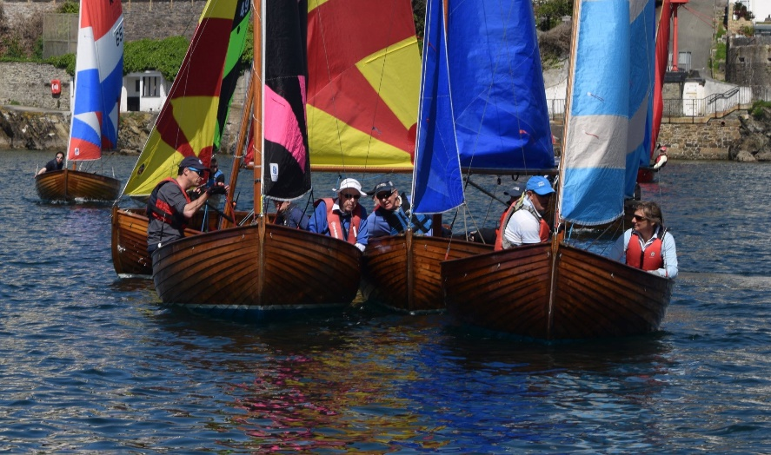
The moulds to build new craft had been lost so Maurice Hunkin made a new set for further craft to be built from 1991 onwards. Maurice built quite a few and Peter Williams at his Bodinnick yard which he took over from Maurice also. More latterly Marcus Lewis has built the latest craft at his works at Windmill in Fowey.
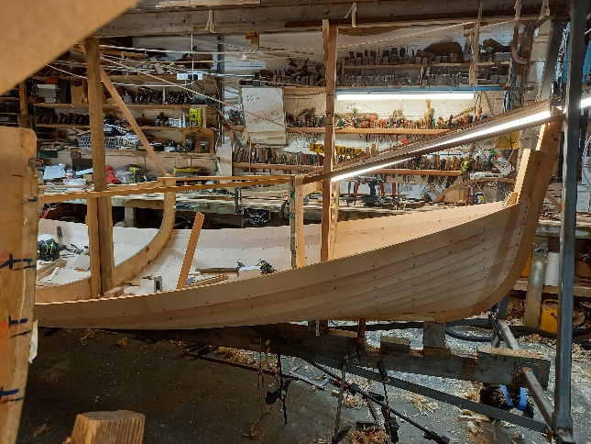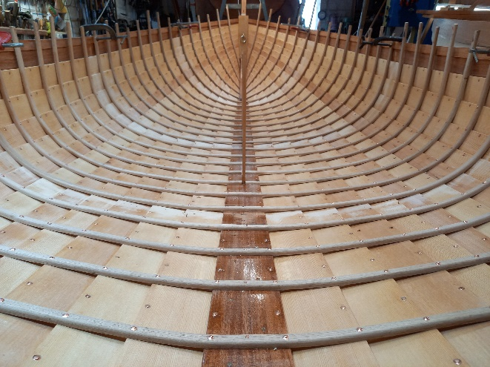
The boats are open i.e. without a foredeck and in gusty conditions can capsize. Each boat is built of Sitka spruce planking ,12 planks per side finished with Khaya mahogany for top plank. Khaya mahogany is also used for seats, the centreplate case whilst the transom and stem are laminated mahogany. The keels are iroko. ribs are oak, steamed and bent into place, copper rivets hold everything together, (about 1350 of them). It takes around 11 weeks work to build one. usually finished in Epifanes single pack varnish, at least 6 coats.
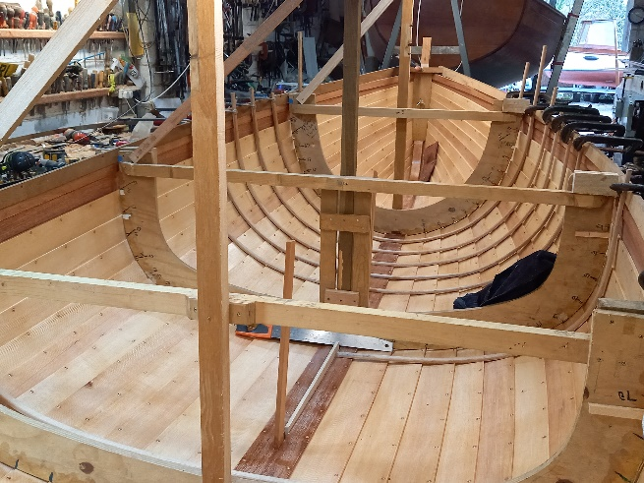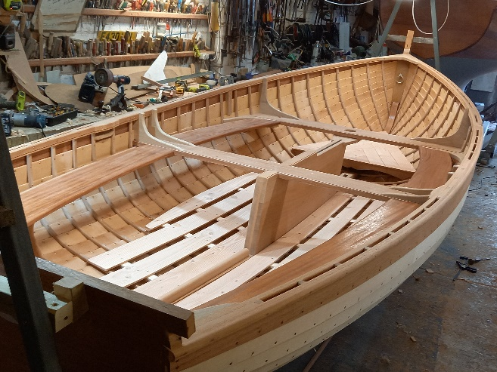
The latest build number 71
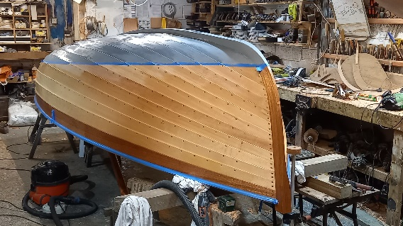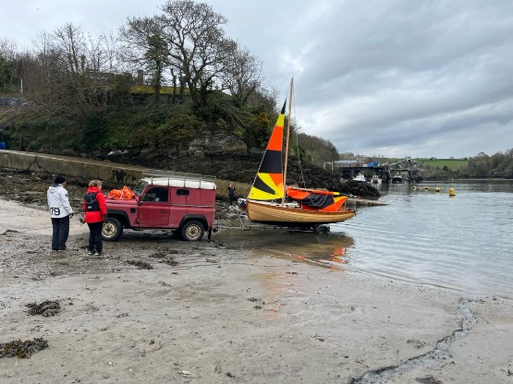
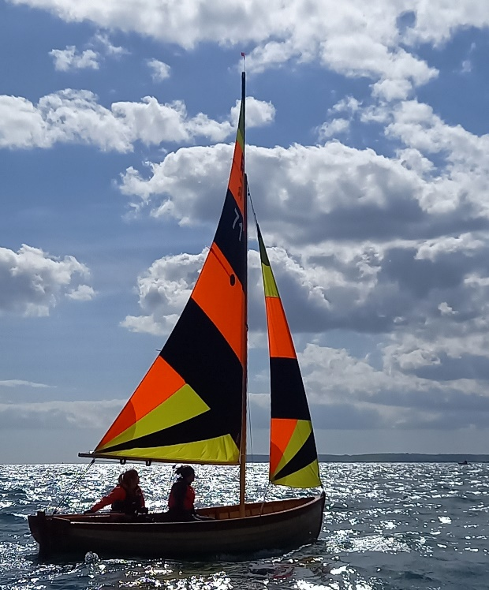
The Craig- B number 71 is the latest to join the fleet although no 72 is on the way.
Probably the best part of the Fowey rivers from a spectators viewing is the multitude of different coloured sails each chosen by the owner and no two are alike.
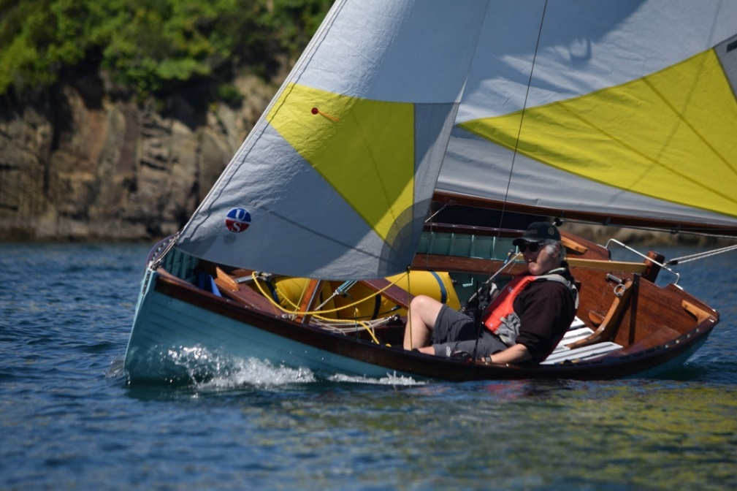
Pictures by Marcus Lewis
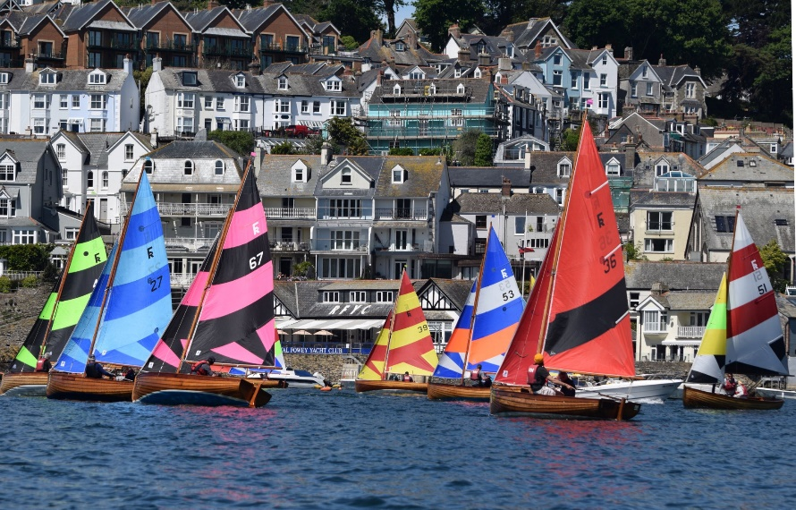
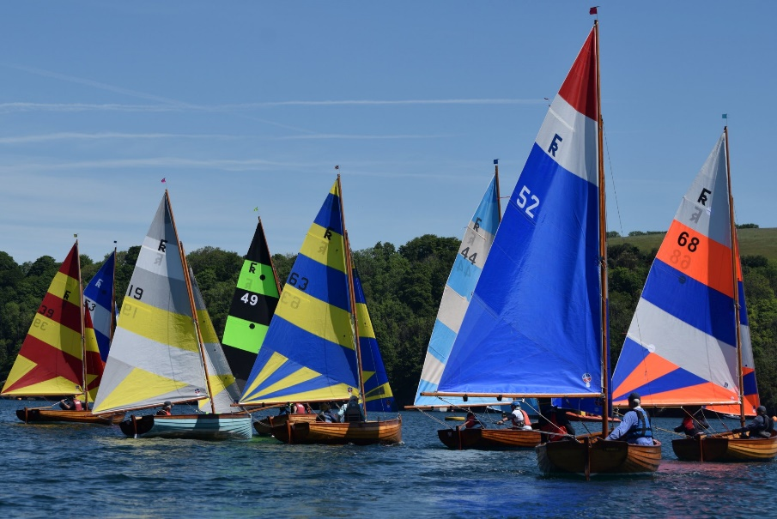
Racing in the 2022 Fowey River championships
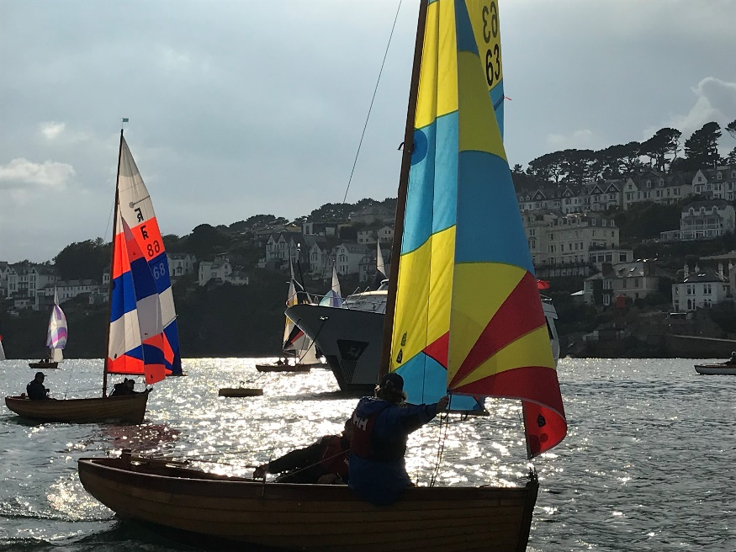
And Wednesday evening racing
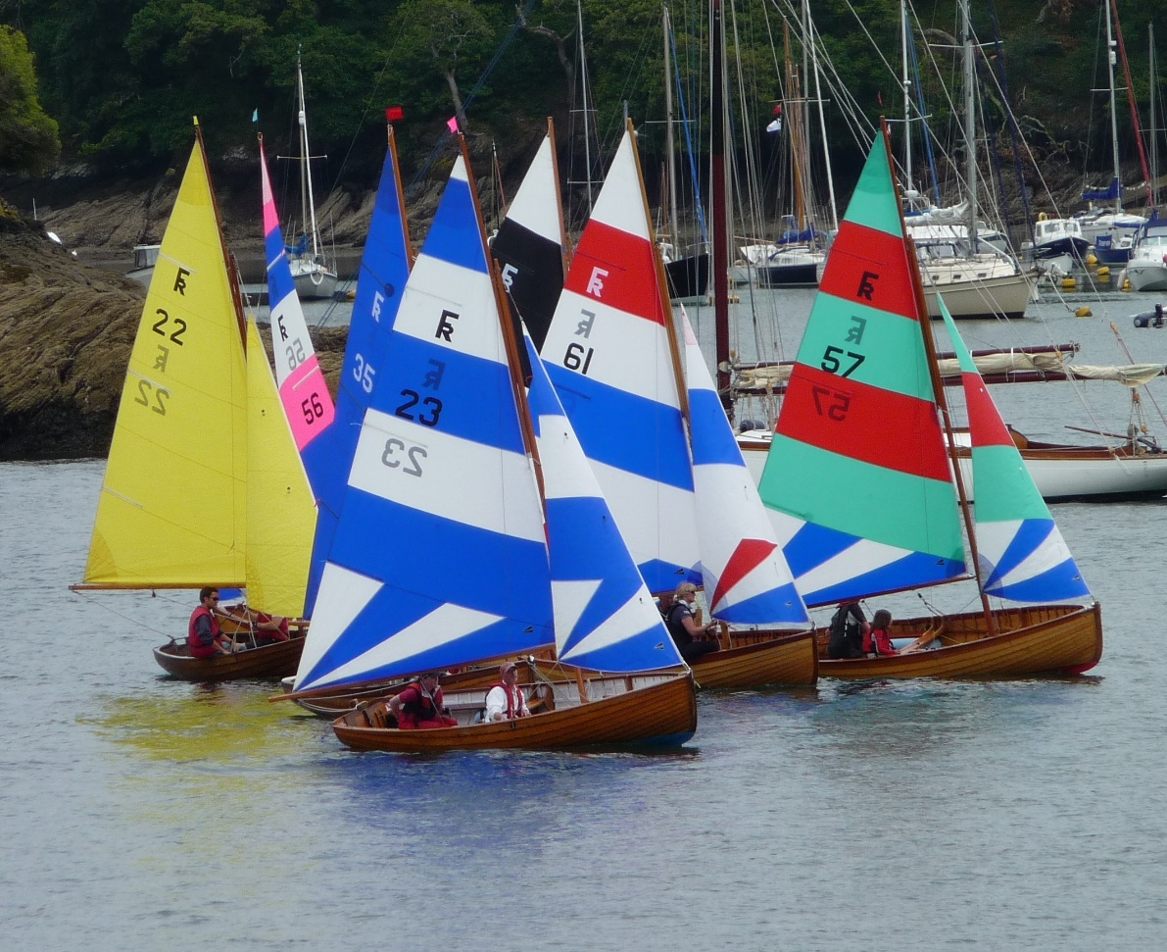
Regatta week start

