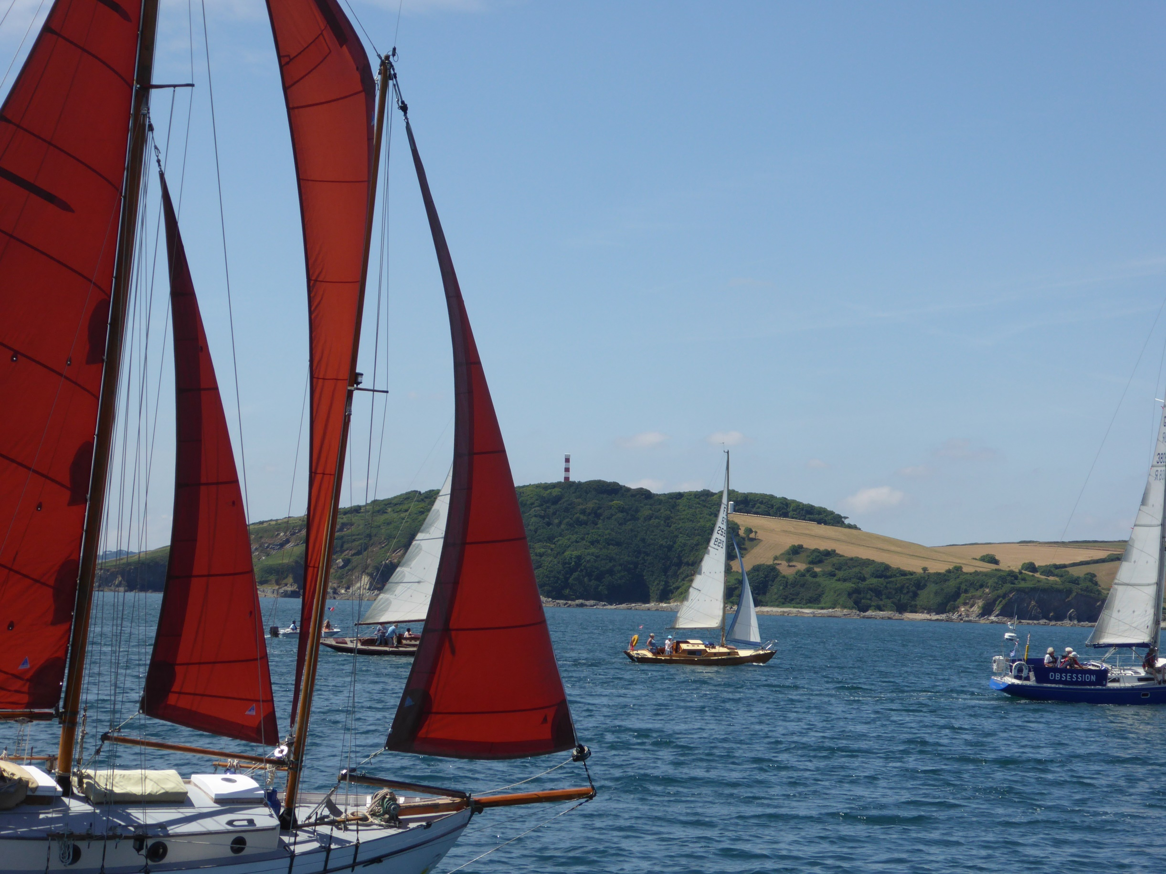

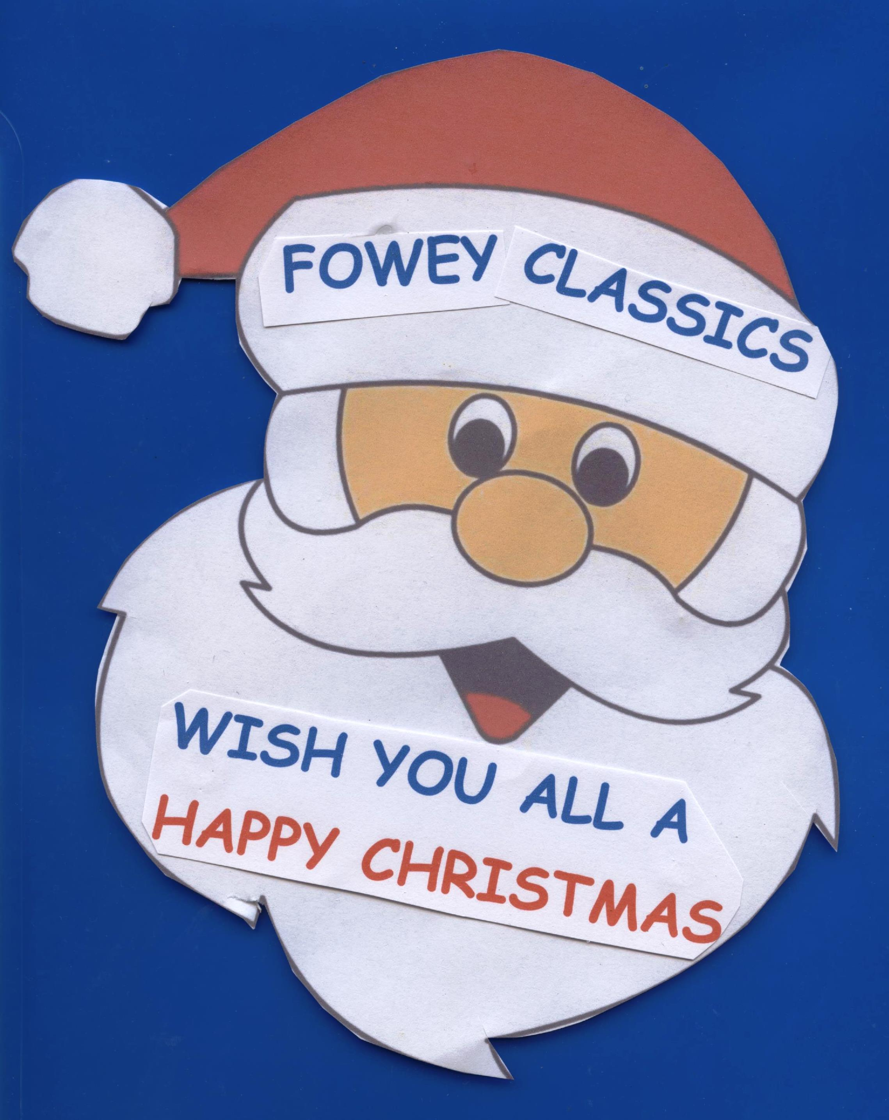





**HAPPY CHRISTMAS, NEW YEAR and 2019 from**

**FOWEY CLASSICS**

**We look forward to seeing you**

**in July 2019**